1. **Boolean** values are the two constant objects False and True

3 different expression that results a Boolean type :

* >>> 5 == (3 + 2) True
* >>> 5 == 6 False
* >>> j = "hel"

>>> j + "lo" == "hello" True

1. Flowcharts is graphically represent the flow of a program.

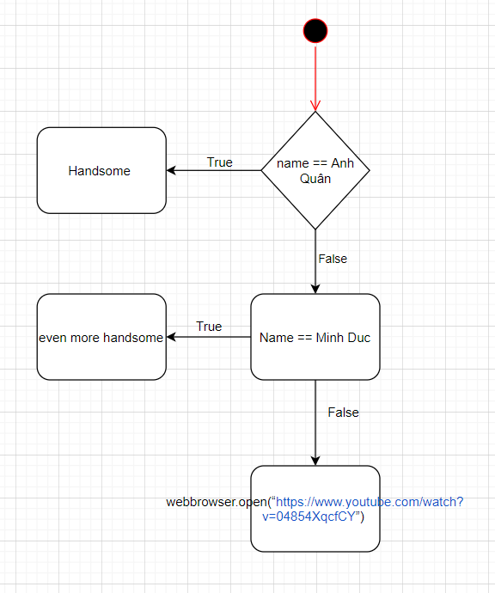

1. A condition that can also be nested in another is called a nested condition.

Ex :

if x < y:

STATEMENTS_A

elif x > y:

STATEMENTS_B

else:

STATEMENTS_C